LAB # 10

Task No 01: Write a program for exam department which provide abstract class and method of Exam type which contains general methods related to exams and can be used by different department for conducting exams.

Code:

Main:

package lab10;

public class Lab10 {

    public static void main(String[] args) {

        MCQExam mcq = new MCQExam("Math", 60, 100, 20, 4);

        EssayExam essay = new EssayExam("English", 90, 100, "The impact of social media on youth");

        mcq.displayDetails();

        mcq.conductExam();

        System.out.println();

        essay.displayDetails();

        essay.conductExam();

    }

}

ExamType (Abstract Class):

package lab10;

public abstract class ExamType {

    String subject;

    int duration;

    int marks;

    public ExamType(String subject, int duration, int marks) {

        this.subject = subject;

        this.duration = duration;

        this.marks = marks;

    }

    abstract void conductExam();

    public void displayDetails() {

        System.out.println("Subject: " + subject);

        System.out.println("Duration: " + duration + " minutes");

        System.out.println("Marks: " + marks);

    }

}

MCQExam (Child Class):

package lab10;

public class MCQExam extends ExamType {

    int questions;

    int options;

    public MCQExam(String subject, int duration, int marks, int questions, int options) {

        super(subject, duration, marks);

        this.questions = questions;

        this.options = options;

    }

    public void conductExam() {

        System.out.println("Conducting MCQ exam with " + questions + " questions and " + options + " options each.");

    }

}

EssayExam (Child Class):

package lab10;

public class EssayExam extends ExamType {

    String topic;

    public EssayExam(String subject, int duration, int marks, String topic) {

        super(subject, duration, marks);

        this.topic = topic;

    }

    public void conductExam() {

        System.out.println("Conducting essay exam on the topic: " + topic);

    }

}

Output:

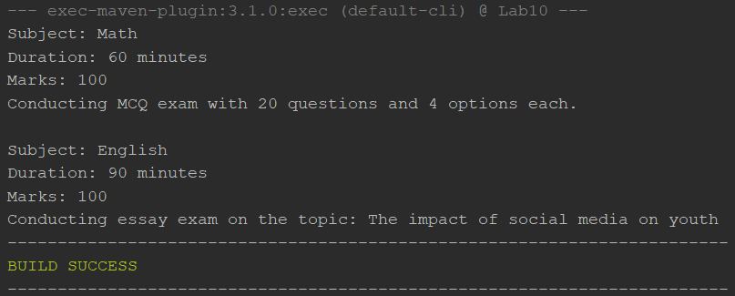

Task No 02: Implement the UML diagram given below. Also Design and implement a subclass “EquilateralTriangle” having a double variable side denoting the three sides of the equilateral triangle [Note that since all the 3 sides are equal, the constructor will have only one parameter]. The area and perimeter of the equilateral triangle are given as follows:

Area = ¼\*\*(*side*)2

Perimeter = 3\**side*

Provide accessor methods for the sides. Test your class using the TestShapes and DownCastingShapes classes.

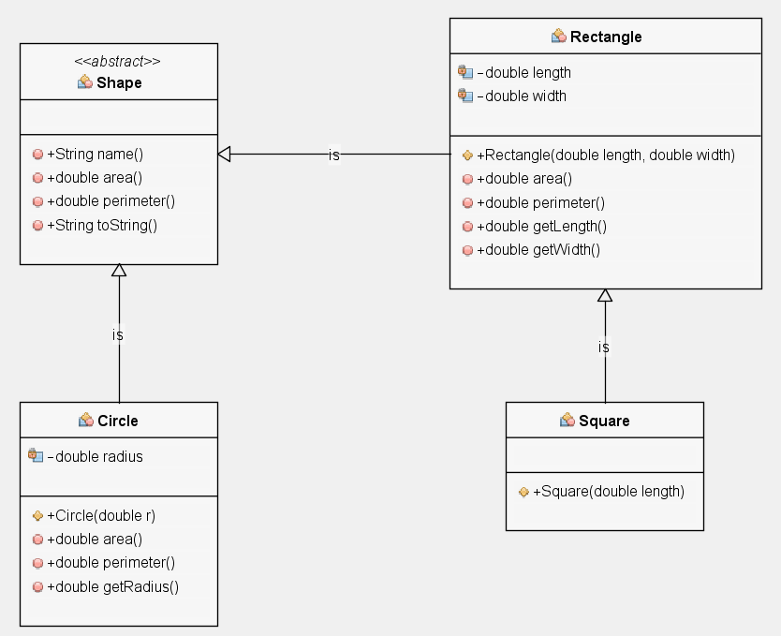

Code:

Main:

Class (Parent):

Class (Child):

Output: